|  |  |
| --- | --- |
| DATE | 14 November 2022 |
| TEAM ID | PNT2022TMID48639 |
| PROJECT TITLE | IoT BASED SMART CROP PROTECTION FOR AGRICULTURE |

**A Database in cloudant DB:**

**STEP 1:**

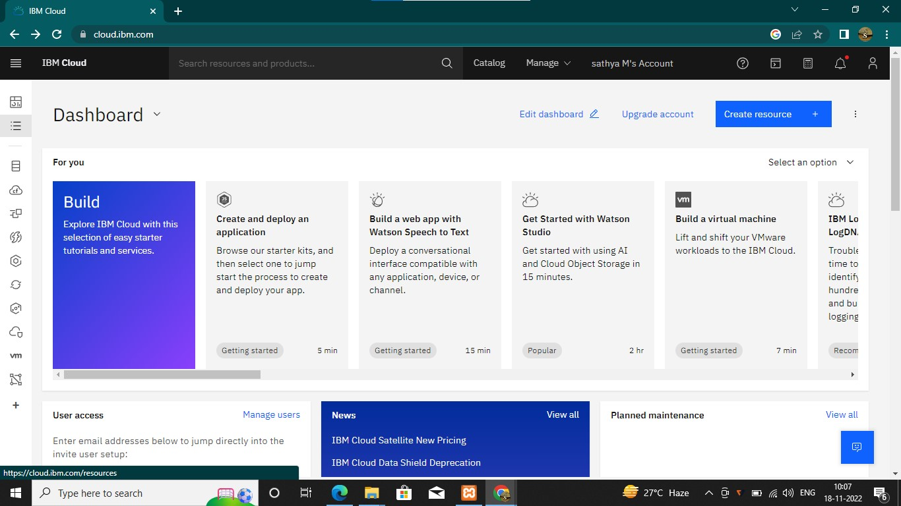

STEP 2:

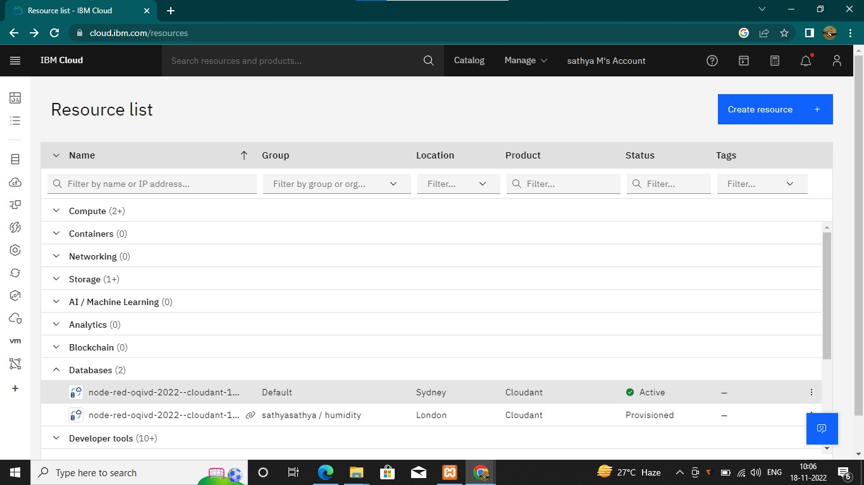

STEP 3:

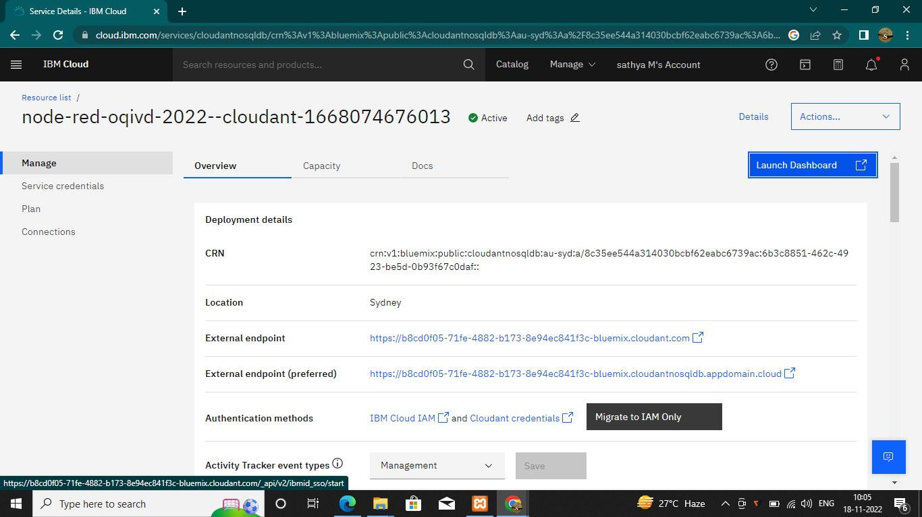

STEP 4:

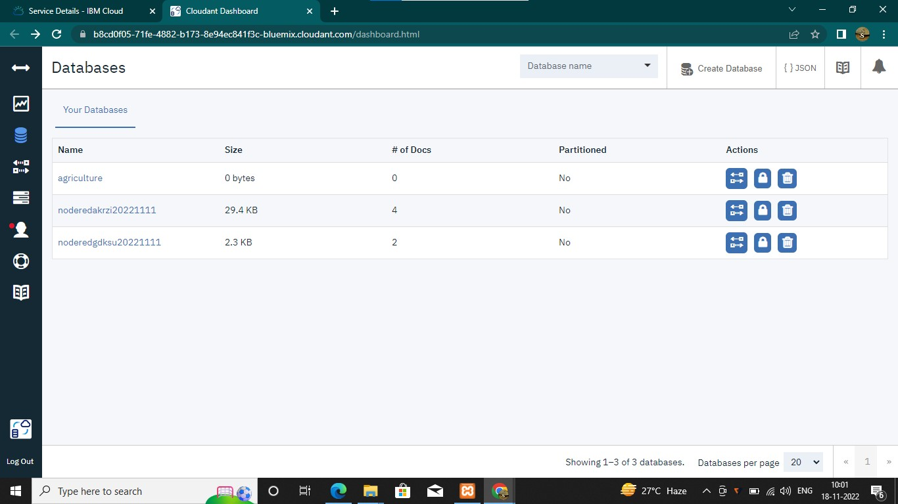

STEP 5:

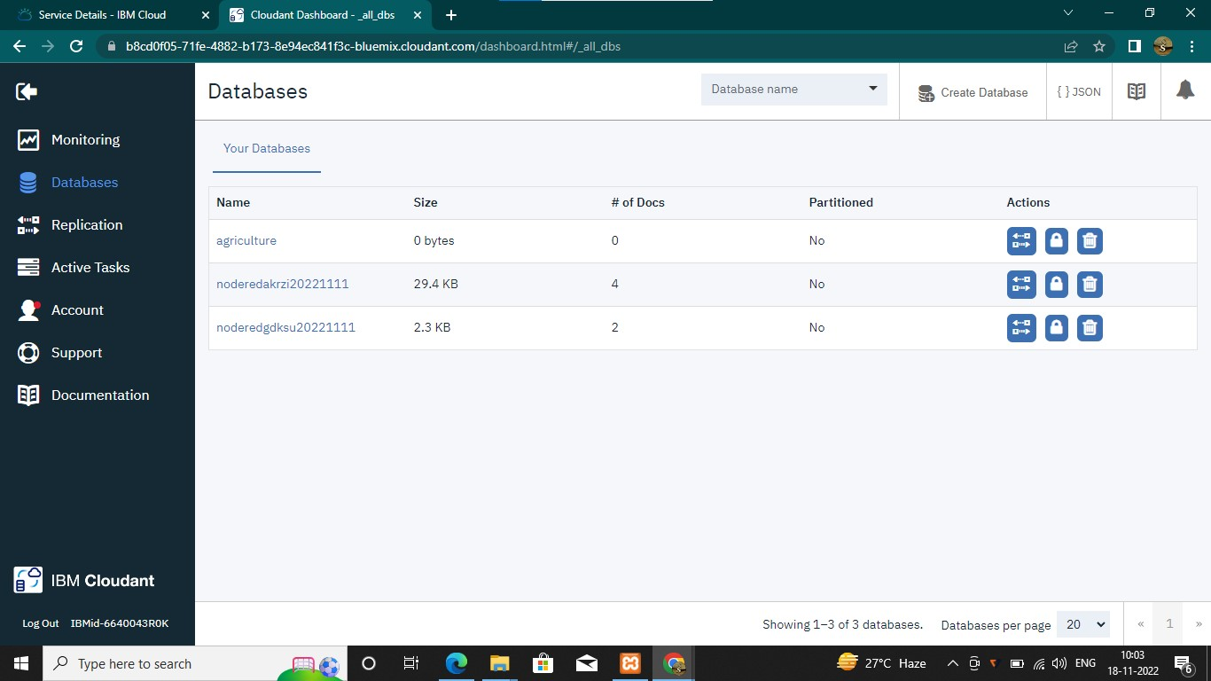

STEP 6:

